Syeda Reeha Quasar

14114802719

4C7

Aim

Write the SQL queries to create the views.

Experiment – 10

DATABASE MANAGEMENT SYSTEMS LAB

# **EXPERIMENT – 10**

## **Aim:**

Write the SQL queries to create the views.

## **Tools Used:**

MariaDB

## **Procedure/ Queries:**

A VIEW is a virtual table, through which a selective portion off the data from one or more tables can be seen will stop views do not contain data of their own will stop they are used to restrict access to the database or to hide data complexity. A view is stored as a SELECT statement in the database.DML operations on a view like INSERT, UPDATE, DELETE affects the data in the original table upon which the view is based.

**Syntax:**

**1.**

CREATE VIEW view_name AS

SELECT column1,column2 ,..

FROM table_name

Where condition;

view_name is the name of VIEW.

The SELECT statement is used to define the columns and rows that you want to display in the view.

**CREATE** **VIEW** sales_order_view **AS** **SELECT** orderno,clientno

**FROM** sales_order;

**SELECT** * **from** sales_order_view;

**2.**

**UPDATE** sales_order_view

**SET** clientno ='C00006'

**WHERE** orderno='019008';

**3.**

**CREATE** **VIEW**_order_details_view **AS**

**SELECT** s.orderno,s.orderdate,s.orderstatus,sd.qtyordered,sd.productrate

**FROM** sales_order s,sales_order_details sd

**WHERE** s.OrderNo=sd.orderno;

Views in SQL are considered as a virtual table. A view also contains rows and columns.

To create the view, we can select the fields from one or more tables present in the database.

A view can either have specific rows based on certain condition or all the rows of a table.

# 1. Creating view

A view can be created using the **CREATE VIEW** statement. We can create a view from a single table or multiple tables.

**Syntax:**

CREATE VIEW view_name AS

SELECT column1, column2.....

FROM table_name

WHERE condition;

# 2. Creating View from a single table

In this example, we create a View named DetailsView from the table Student_Detail.

**Query:**

CREATE VIEW DetailsView AS

SELECT NAME, ADDRESS

FROM Student_Details

WHERE STU_ID < 4;

Just like table query, we can query the view to view the data.

SELECT * FROM DetailsView;

# 3. Creating View from multiple tables

View from multiple tables can be created by simply include multiple tables in the SELECT statement.

In the given example, a view is created named MarksView from two tables Student_Detail and Student_Marks.

**Query:**

CREATE VIEW MarksView AS

SELECT Student_Detail.NAME, Student_Detail.ADDRESS, Student_Marks.MARKS

FROM Student_Detail, Student_Mark

WHERE Student_Detail.NAME = Student_Marks.NAME;

To display data of View MarksView:

SELECT * FROM MarksView;

#### 4. Deleting View

A view can be deleted using the Drop View statement.

**Syntax**

DROP VIEW view_name;

**Example:**

If we want to delete the View **MarksView**, we can do this as:

DROP VIEW MarksView;

* OUTPUT :

1. Creating a view :

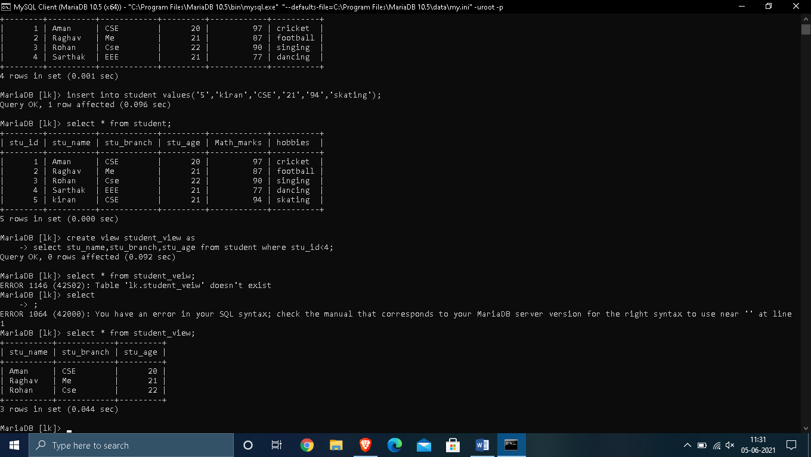



## 2. . Creating View from multiple tables

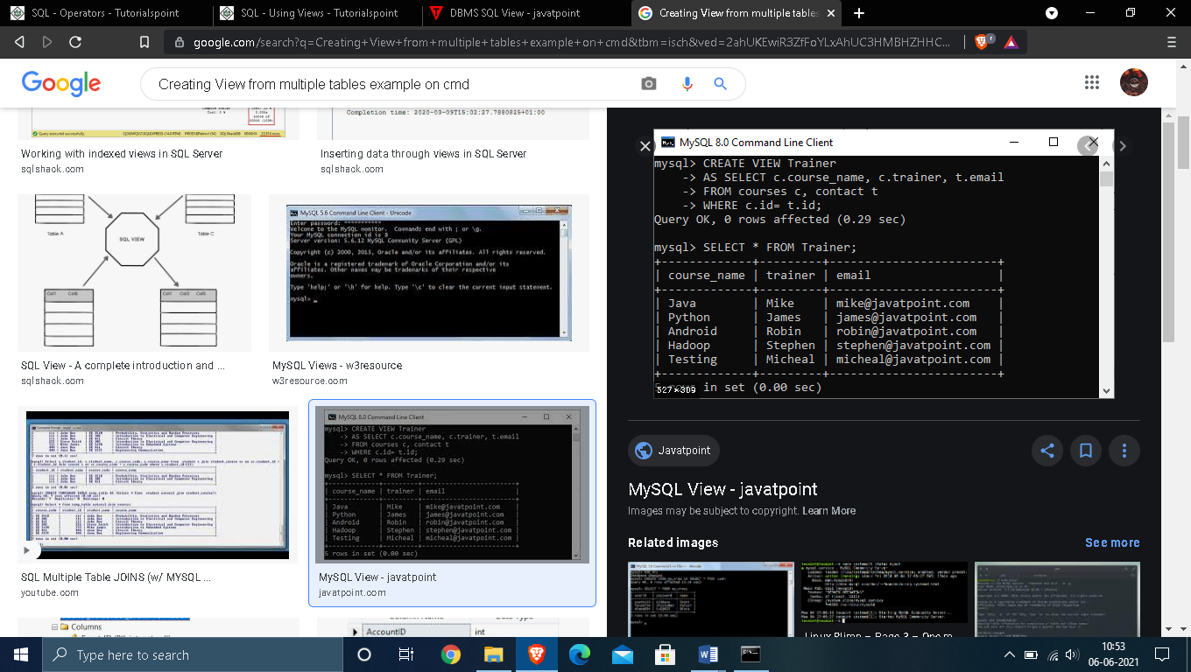

## 3.  Deleting View

## 

# VIVA QUESTIONS

## Q.1: What is a VIEW?

**Ans:**

Views in SQL are kind of virtual tables. A view also has rows and columns as they are in a real table in the database. We can create a view by selecting fields from one or more tables present in the database. A View can either have all the rows of a table or specific rows based on certain condition. They are used to restrict access to the database or to hide data complexity. A view is stored as a SELECT statement in the database. DML operations on a view like INSERT, UPDATE, DELETE affects the data in the original table upon which the view is based.

## Q.2: How we create a VIEW?

**Ans:**

A view is a virtual table based on the result set of an SQL statement. The CREATE VIEW command creates a view. At first, we need to specify the **CREATE VIEW**statement and then we have to give a name to the view. In the second step, we define the **SELECT** statement after the **AS** keyword. Views can be created from a single table, multiple tables or another view. The basic CREATE VIEW syntax is as follows −

CREATE VIEW view_name AS

SELECT column1, column2.....

FROM table_name

WHERE [condition];

## Q.3: What is the purpose of creating a VIEW?

**Ans:**

Views are used to limit the visibility of data of the table to just those specific tasks. Also, the view is used for combining the data from multiple tables into a logical table. Views can be used to aggregate rows (using GROUP BY and HAVING) of a table with better detail. The view is used to summarize the data from multiple tables so that views can be used to generate reports.  Views can simplify support legacy code. If you need to refactor a table that would break a lot of code, you can replace the table with a view of the same name. The view provides the exact same schema as the original table, while the actual schema has changed. This keeps the legacy code that references the table from breaking, allowing you to change the legacy code at your leisure. Views are used for security purposes because they provide encapsulation of the name of the table. Data is in the virtual table, not stored permanently. Views display only selected data.

## Q.4: What is the syntax of creating a VIEW?

**Ans:**

The basic CREATE VIEW syntax is as follows −

CREATE VIEW view_name AS

SELECT column1, column2.....

FROM table_name

WHERE [condition];

## Q.5: How many VIEWS can be created for a table?

**Ans:**

Database users can create multiple VIEWS from a table, thus one view can aggregate data from other views.